H.T No
Regulations:
A20

Sreenidhi Institute of Science and Technology
(An Autonomous Institution)
Code No: 8B103 Date: 19-September-2024 (AN)

B.Tech I-Year I- Semester External Examination, September-2024 (Supplementary)
ENGINEERING MECHANICS(ME)

Time: 3 Hours Max.Marks:70

Note: a) No additional answer sheets will be provided.
b) All sub-parts of a question must be answered at one place only, otherwise it will not be valued.
c) Missing data can be assumed suitably.

Bloom's Cognitive Levels of Learning (BCLL)

Remember | L1 | Apply | L3 | Evaluate | L5
Understand | L2 | Analyze | L4 | Create | L6

Part - A Max.Marks:20
Answer all QUESTIONS

 |  | BCLL | CO(s) | Marks
1 | State triangle law of forces and polygon law of forces. | L1 | CO1 | [2M]
2 | What is the advantage of method of section over method of joints? | L1 | CO2 | [2M]
3 | Define angle of friction and angle of repose. | L1 | CO3 | [2M]
4 | Write down the position of centroid of the quarter circle. | L1 | CO4 | [2M]
5 | Define the terms angular velocity and angular acceleration | L1 | CO5 | [2M]
6 | State and derive the work-energy principle. | L1 | CO6 | [2M]
7 | State the parallelogram law of forces | L1 | CO1 | [2M]
8 | State the theorem of perpendicular axis applied to moment of inertia. | L1 | CO4 | [2M]
9 | Define the terms ‘collision of elastic bodies’. Discuss the phenomenon of collision. | L1 | CO5 | [2M]
10 | Write a short note on virtual work principle and its applications. | L1 | CO6 | [2M]
Part – B Max.Marks:50
ANSWER ANY FIVE QUESTIONS. EACH QUESTION CARRIES 10 MARKS.

 |  |  | BCLL | CO(s) | Marks
11. | a) | The greatest and least resultants of two forces F1 and F2 are 17 N and 3 N respectively. Determine the angle between them when their resultant is √149 N. | L2 | CO1 | [5M]
 | b) | What is a free body diagram? Explain with a suitable example. | L1 | CO1 | [5M]
12. |  | Find the force acting in all members of the truss shown in Figure  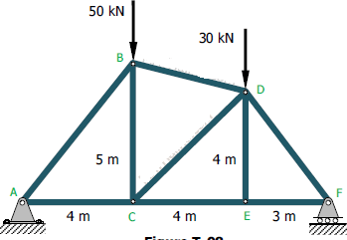 | L3 | CO2 | [10M]
13. |  | Locate the centroid of the shaded area shown in figure 3  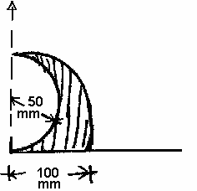 | L3 | CO3 | [10M]
14. |  | Determine the mass moment of inertia of sphere about its diametrical axis | L3 | CO4 | [10M]
15. |  | A projectile fired from the edge of a 150 m high cliff with an initial velocity of 180 m/s at an angle of elevation of 30° with the horizontal. Neglecting air resistance find :  1. The greatest elevation above the ground reached by the projectile ; and  2. Horizontal distance from the gun to the point, where the projectile strikes the ground. | L3 | CO5 | [10M]
16. |  | Two bodies weighing 300N and 450N are hung to the two ends of a rope passing over an ideal pulley as shown in fig. With what acceleration will the heavier body come down? What is the tension in the string? | L3 | CO6 | [10M]
17. | a) | State and explain Varignon’s Theorem. | L1 | CO1 | [4M]
 | b) | Explain the term ‘support reactions.’ What are the different types of support ? | L3 | CO2 | [3M]
 | c) | What is the difference between the centre of gravity, centre of mass and centroid? | L3 | CO3 | [3M]
18. | a) | Explain the procedure to find polar moment of inertia of masses | L3 | CO4 | [4M]
 | b) | Define the terms: Time of accent, time of decent, time of flight, projectile, horizontal range, work & power. | L1 | CO5 | [3M]
 | c) | State D’Alembertz Principle. | L1 | CO6 | [3M]
-- 00 -- 00 –

